## Project 1

## Deploy a static website on AWS



Table of content

1. Introduction
2. Overview Of What You’ll Build
3. Step By Step Guide
4. Testing

*Introduction*

Deploying a static website on AWS typically involves using Amazon S3 (Simple Storage Service) to host the website's files and Amazon CloudFront for content delivery and HTTPS support. This provides a cost-effective and scalable solution for serving static content. You can also leverage AWS Amplify for a more streamlined deployment process, especially for single-page applications.

## Overview of What You'll Build

You’ll deploy your static website (HTML, CSS, JS) using:

* **Amazon S3** – To host your site files.
* **CloudFront** (optional but recommended) – To serve your site globally with CDN caching.
* **Route 53** (optional) – For custom domain (e.g., www.example.com).
* **AWS Certificate Manager (ACM)** – For HTTPS with a custom domain.

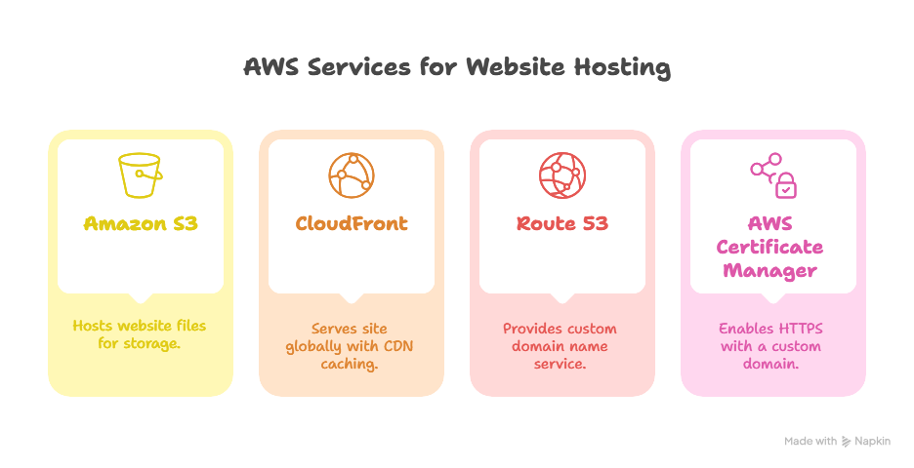

Step-by-Step Guide

### ****Step 1: Prepare Your Website Files****

Make sure your site files include:

* index.html
* Any CSS/JS/images in folders

Compress everything into a local folder, like my-website/.

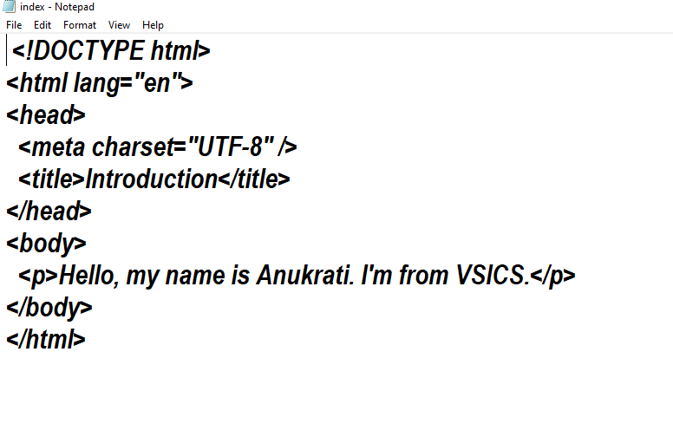

### Step 2: ****Create an S3 Bucket****

* Go to **S3 Console** → **Create bucket**

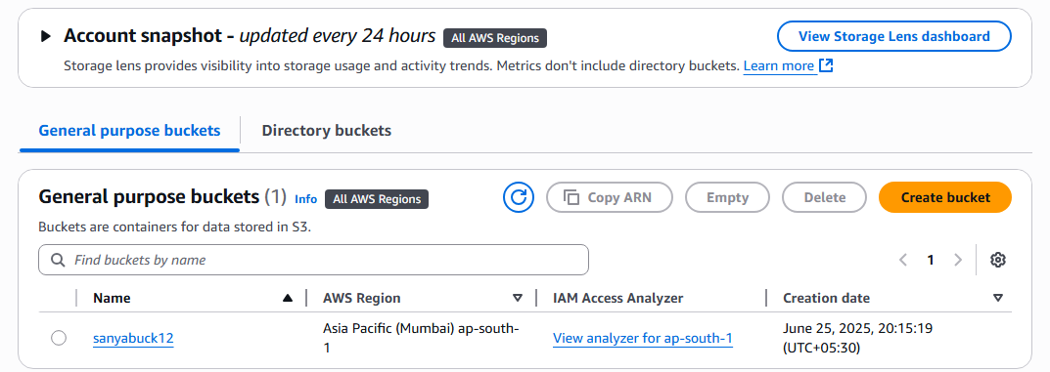

* Bucket name: Must match your domain name (e.g., [www.anukrati.com](http://www.anukrati.com))

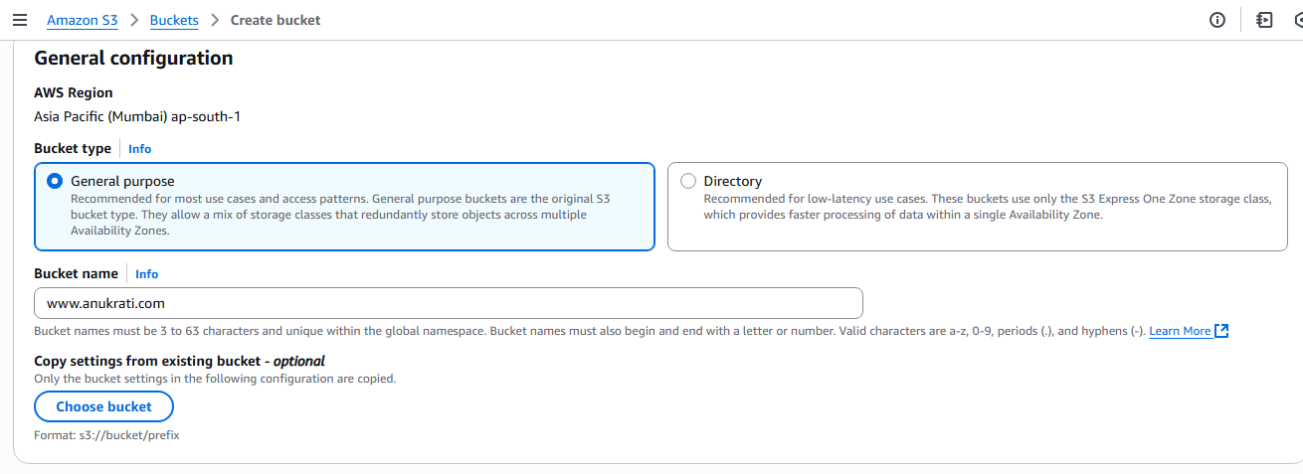

* Disable **Block all public access**

• Enable **Static website hosting** under the bucket **Properties** tab

* Set:
* **Index document**: index.html
* (Optional) **Error document**: error.html

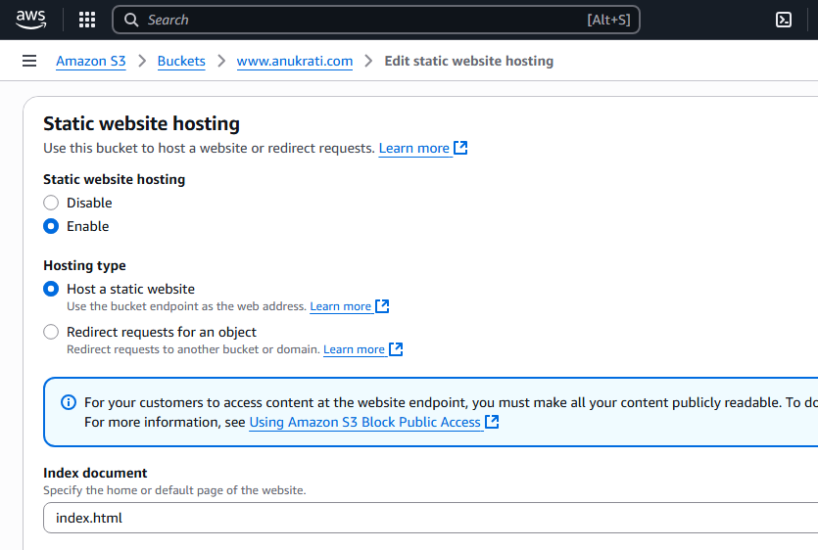

#### Upload Files

Go to the **Objects** tab → **Upload** your index.html and related files.

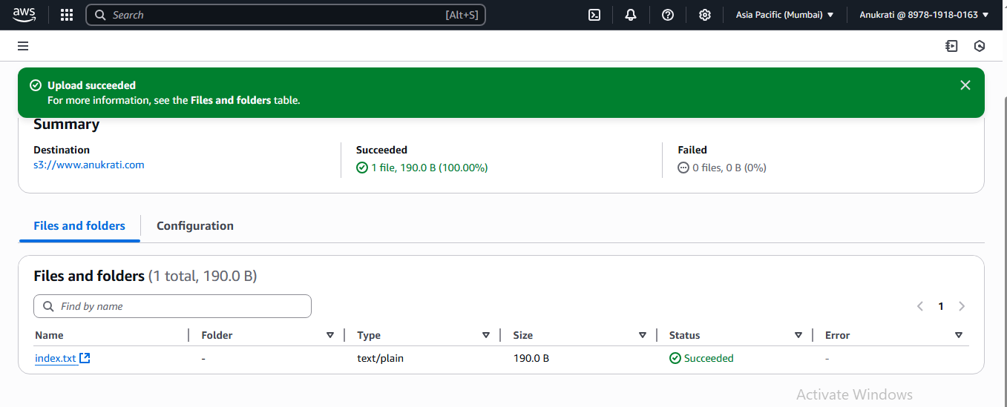

### Step 3: ****Make Files Public (Static Hosting)****

Add a **bucket policy** to allow public read access:

json

CopyEdit

{

"Version": "2012-10-17",

"Statement": [

{

"Sid": "PublicReadGetObject",

"Effect": "Allow",

"Principal": "*",

"Action": "s3:GetObject",

"Resource": "arn:aws:s3:::your-bucket-name/*"

}

]

}

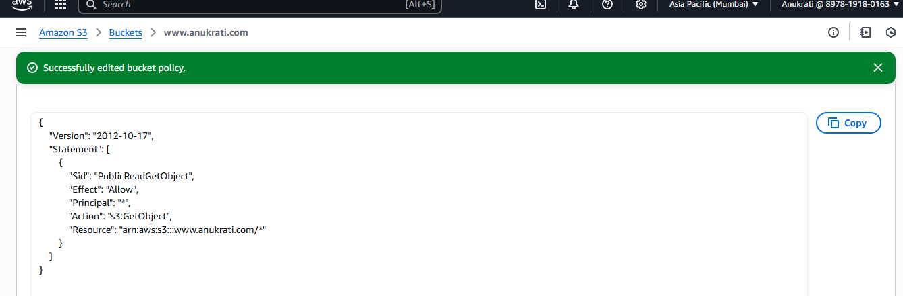

Replace your-bucket-name accordingly.

### Step 4: ****Access Your Website****

Go to **Properties > Static website hosting**, and use the **Endpoint URL** to view your site.

Example: http://your-bucket-name.s3-website-us-east-1.amazonaws.com

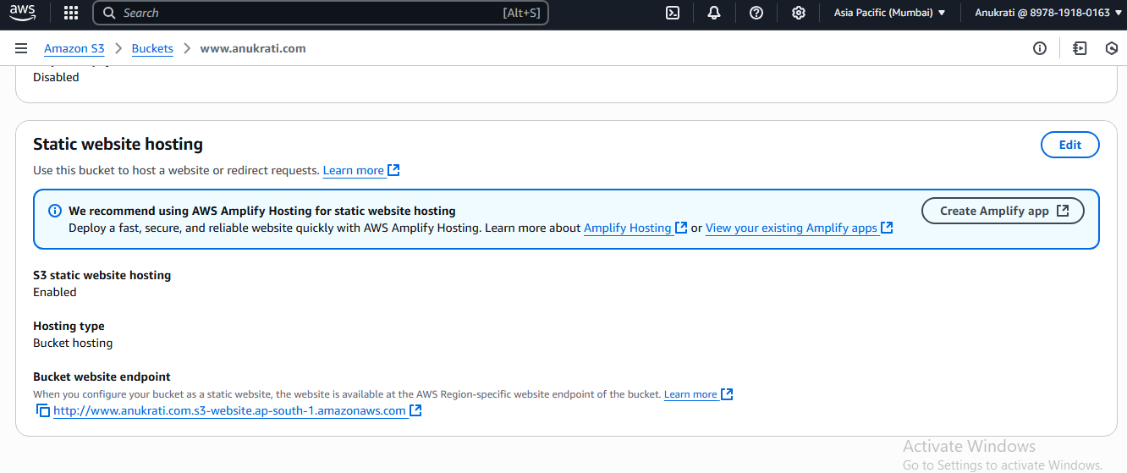

## Testing

* Try accessing the site via the S3 static URL or your custom domain.
* Make sure pages load correctly and HTTPS is enabled if configured.